14 Throughput Controller



This section will guide you to understand:

* How to check throughput controller

**Development Environment:**

* Apache JMeter 5.1.1 Version
* JDK Runtime Environment 11.0.2

This guide has five subsections, namely:

1.14.1 Loading distribution of users

1.14.2 Adding throughput controllers

1.14.3 Performing normal execution testing in throughput controller

1.14.4 Performing percentage execution testing in throughput controller

1.14.5 Pushing the code to GitHub repositories

**Step 1.14.1:** Loading distribution of users

* Let’s take an example of “www.lifecharger.org” website.
* This website contains some pages like: Home page,About page and Archives page.



**Step 1.14.2:** Adding throughout controller

* Right click on Thread Group.
* Click on Add -> Logic Controller ->Throughput Controller.

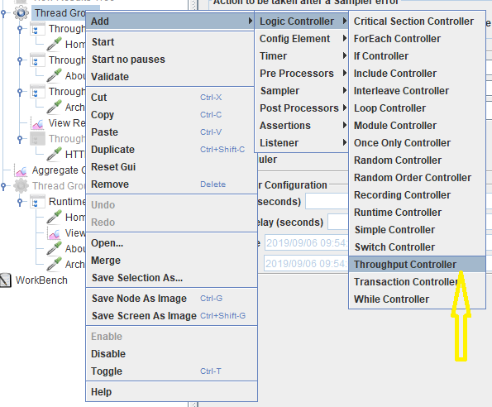

* Right click on the Throughput Controller.
* Click on Add -> Sampler -> HTTP Request.

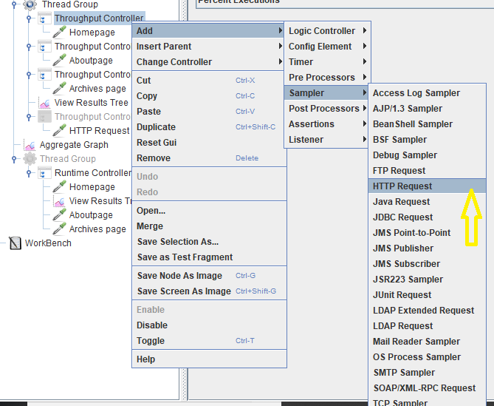

* Rename HTTP Request as HomePage.
* Give an IP address.
* Path should be kept empty because the website landing page is homepage.

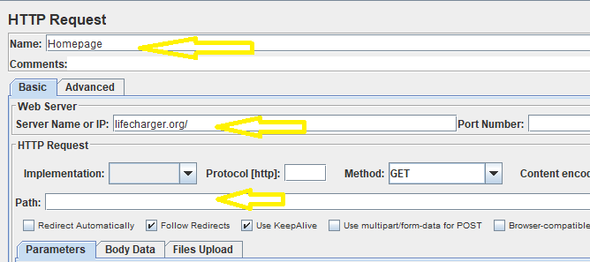

* Create another throughput controller.
* Add HTTP request and rename as About Page.



* Give an IP address.
* Fill the Path box.

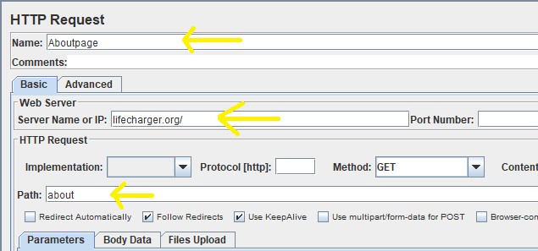

* Create another throughput controller.
* Add HTTP request and rename it as Archive Page.

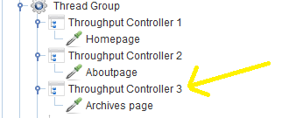

* Give an IP Address.
* Fill the Path box.

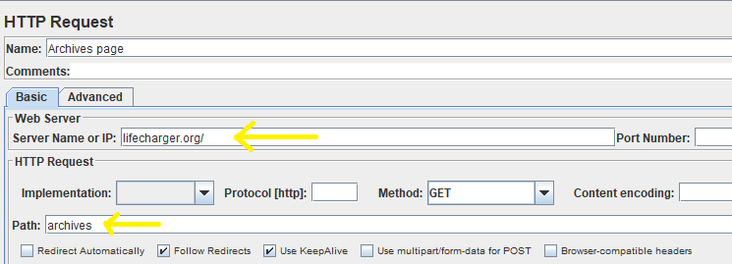

* Right click on Thread Group.
* Click on Add -> Listener -> Aggregate graph.

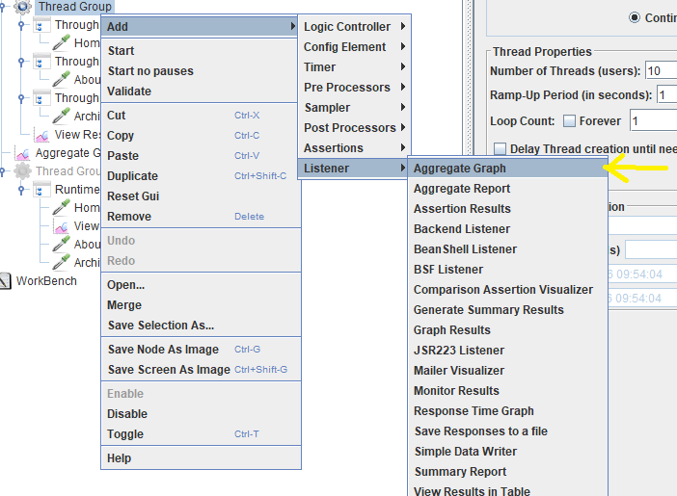

**Step 1.14.3:** Performing total execution testing in throughout controller

* The number given for throughput will be the total number of executions for the current controller.
* In Thread Group, consider 10 concrete users and the loop count as 1 (concrete users optional).

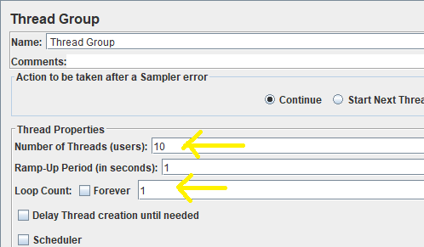

* Throughput Controller should be in Total Executions.
* Click on the check box “per user”.
* Create three throughput controllers as shown below.
* Create Throughput Controller 1 and give ‘Throughput’ as 2.

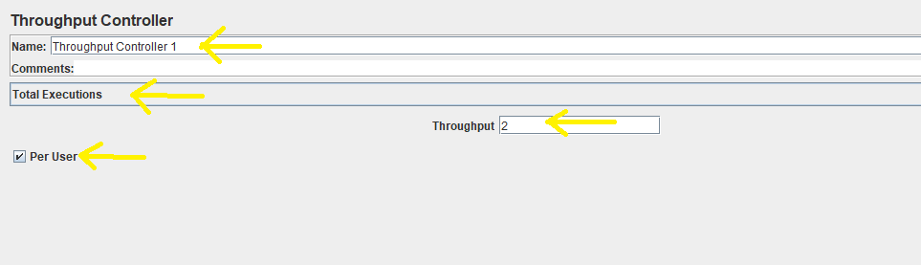

* Next, create Throughput Controller 2 and give ‘Throughput’ as 3.

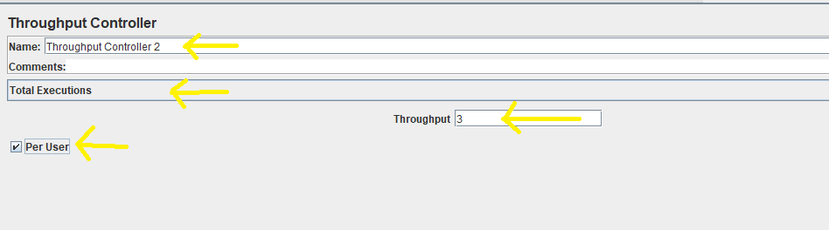

* Again, create Throughput Controller 3 and give ‘Throughput’ as 5.

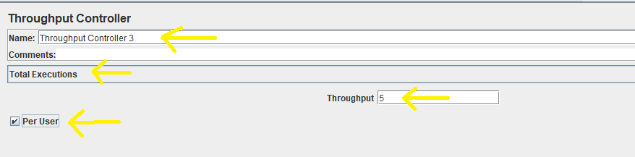

* Run the throughput controller and view the results as shown below:

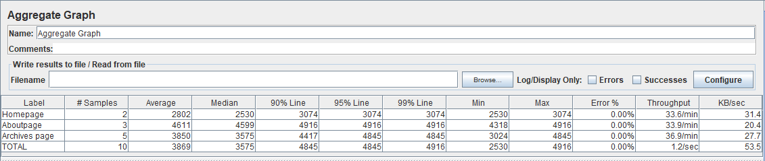

**Step 1.14.4:** Performing percentage execution testing in throughout controller

* In Thread Group, consider 10 concrete users and loop count 1 (concrete users optional).



* Throughput Controller should be in Percentage Executions.
* Throughput Controller is optional.
* Uncheck the checkbox “per user”.
* Create three Throughput Controllers as shown below.
* Create Throughput Controller 1 and consider 20% as Throughput.

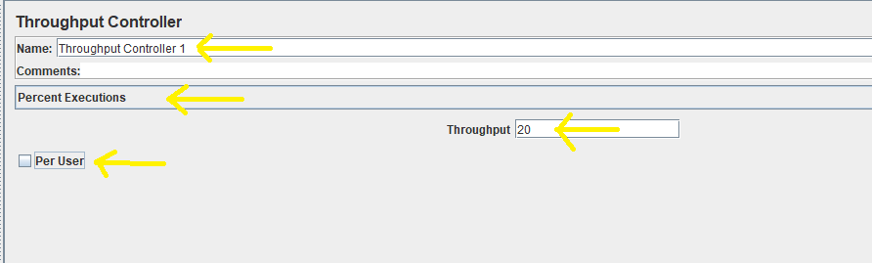

* Create Throughput Controller 2 and consider 30% as Throughput.

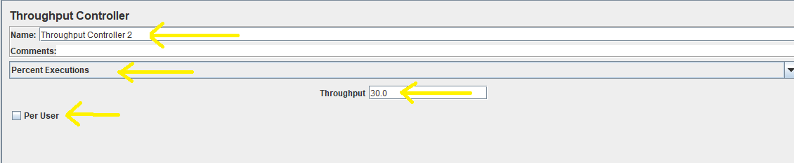

* Create Throughput Controller 3 and consider 50% as Throughput.

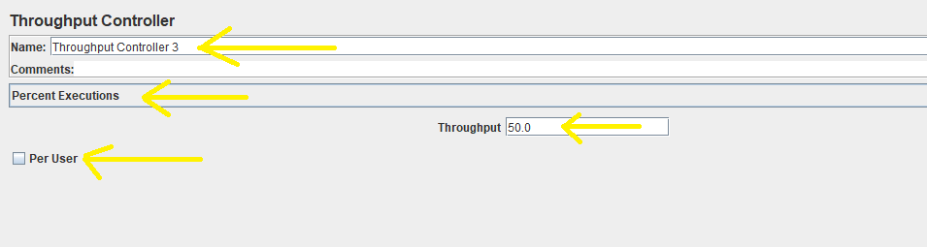

* Run the Throughput Controller and view the results as shown below:



**Step 1.14.5:** Pushing the code to GitHub repositories

Open your command prompt and navigate to the folder where you have created your files.

cd <folder path>

Initialize your repository using the following command:

git init

Add all the files to your git repository using the following command:

git add . 

Commit the changes using the following command:

git commit . -m “Changes have been committed.”

Push the files to the folder you initially created using the following command:

git push -u origin master